Instructions for Secure Printing:

Go to Windows Icon and then select Devices and Printers

Select the Sharp printer/copier you send your documents to and {Right Click} that printer to get the following pop up window. Please select “Printing Preferences”.
In the Printing Preferences window, select the “Job Handling” tab. In this tab, do the following:
- Click on the “Retention” check box.
- Click on “Hold Only” radio button.
- Click on “Password” check box.
- Enter a 5 digit numerical password in the box below the Password check box.
- Click on “Apply” at the bottom of the window.
- Click on “Ok”

The next time you print to this printer, go to the printer and select “Document Filing” on the on screen menu.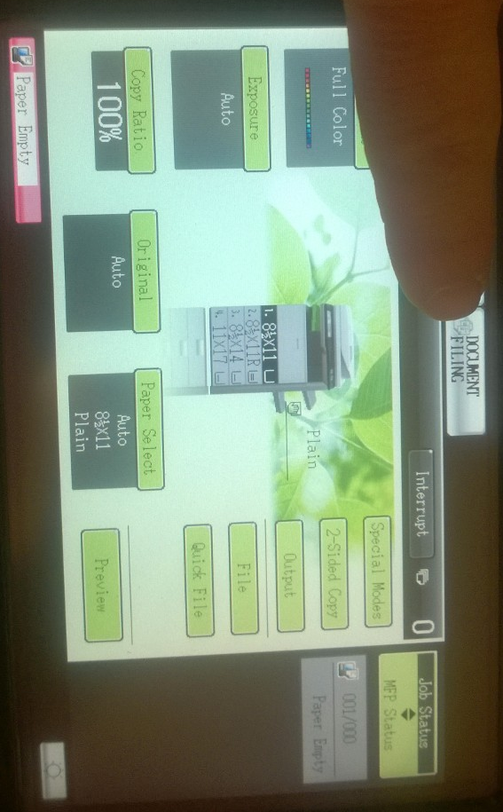
Under the “File Retrieve” tab, select “Main Folder”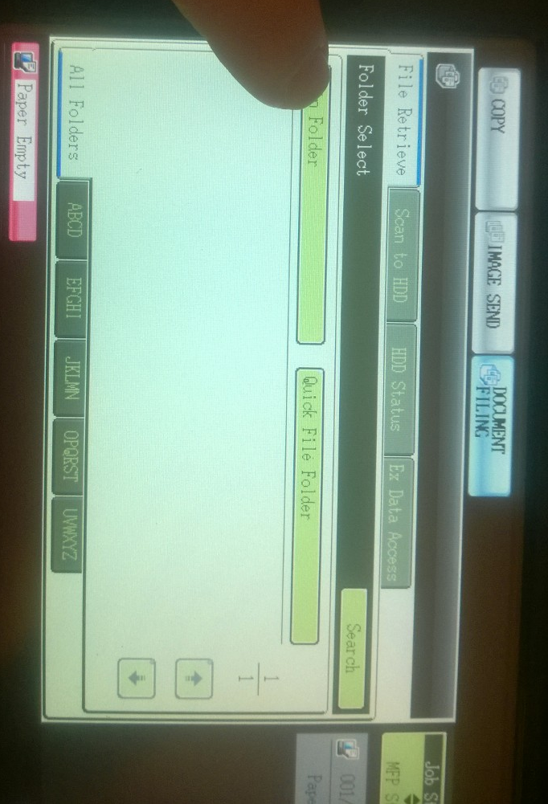
In the list of print jobs, locate and tap on your print job.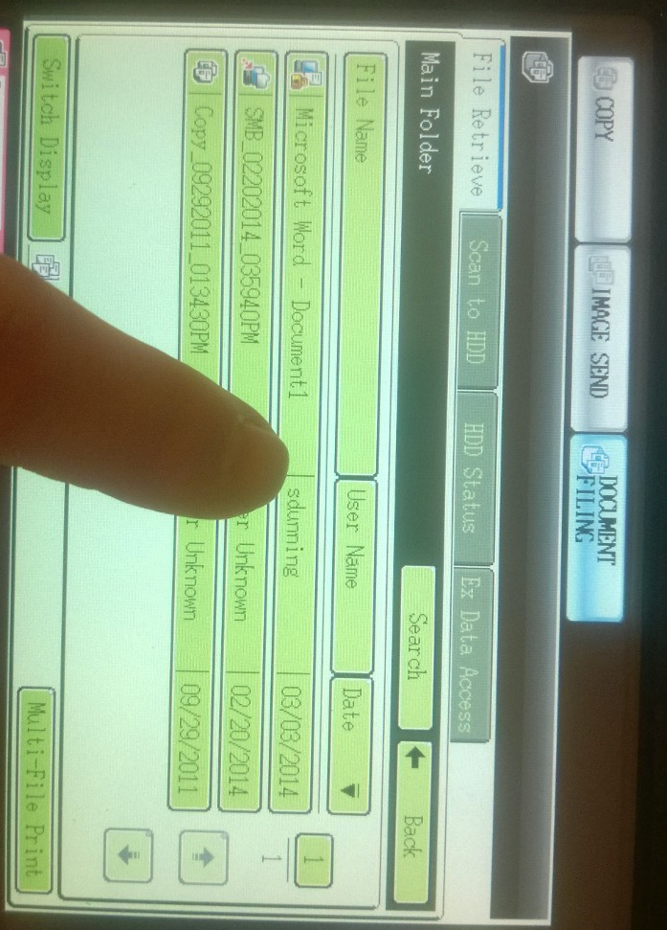
The printer will now ask for the 5 digit password you entered at your computer. Enter the 5 digit password and select “OK”.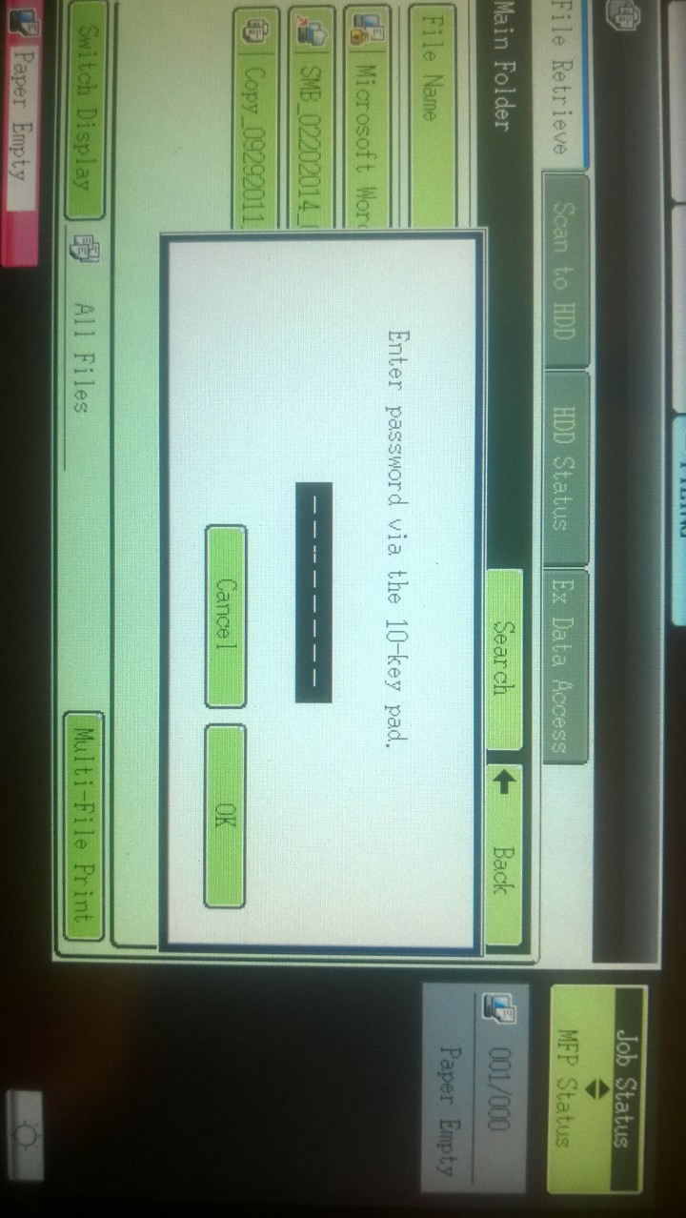
In “Job Settings”, tap on “Print”.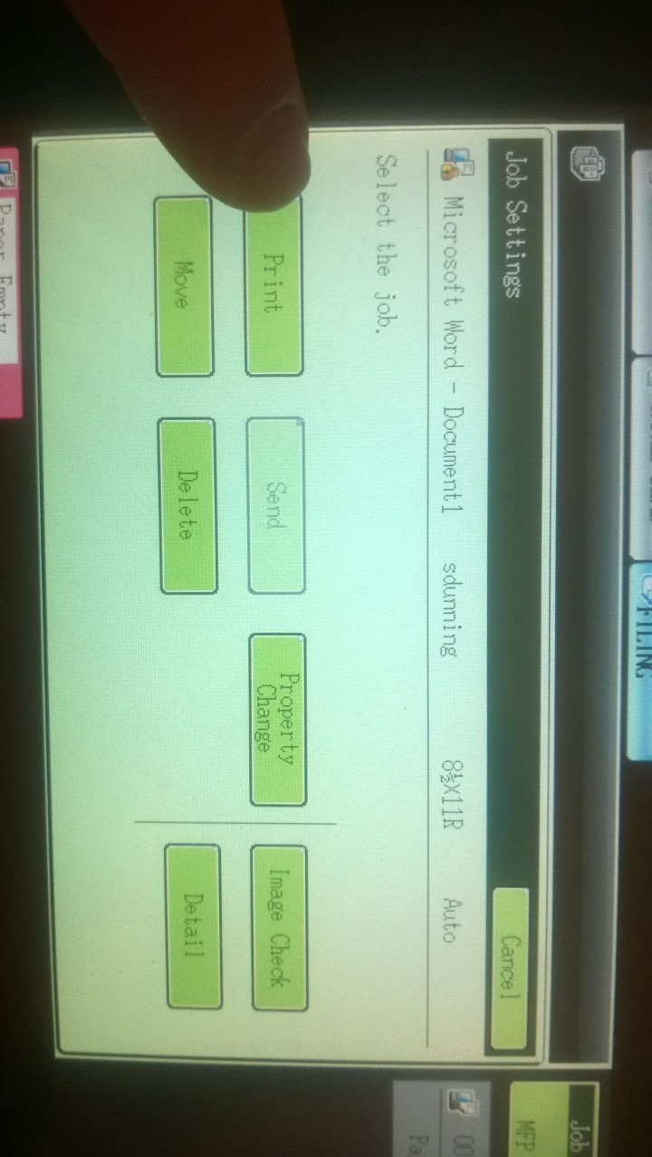
In “Job Settings / Print”, tap on “Print and Delete the Data”.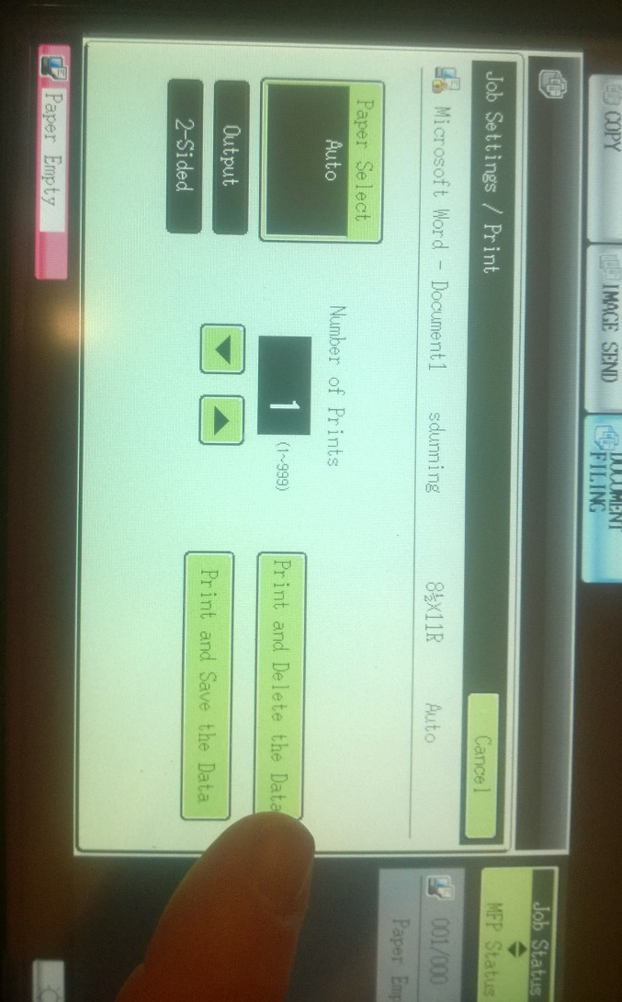
This will print your print job and delete it from the stored print jobs.

