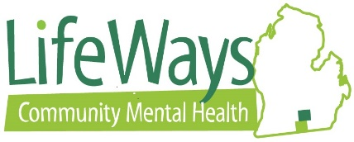
Event Request Form
Name and Title of Requester
Name of Supervisor
Date of Request
Type of Event: | Training Conference Seminar Webinar  Other
Date(s) of Event |  |  | Location of Event (City, State)
Event Title
Hosting Organization Name and Billing Address (street, city, zip)
Description of Event
Date(s) of Travel |  |  | Was this budgeted?
Cost Center Coding
Out-of-State Travel? (If yes, requires Board approval in advance)
Does this require air travel? If yes, please give your date of birth (required by airlines at ticketing)
Emergency Contact Name/Number
Estimated Cost | $ | Event Cost / Registration Fee
 | $ | Hotel
 |  | Transportation Costs: |  | $ |  | Flight
 | $ | Rental Car |  | $ |  | Parking
 | $ | Mileage |  | $ |  | Tolls
 | $ | Meals / Per Diem (info must be submitted 3 weeks in advance for per diem payout, if applicable)
 | $ | Misc. (Explain)
 | $ | Total Estimated Cost
Event Information Attached? (must be attached for MNJTP Approval as well as for per diem) | Yes  No (please explain)
Supervisor Approval | Yes (initial, send copies of all documents to Latrelle Burk for processing, return originals to employee)  No (return to originator/meet with employee to discuss)
CEO Approval (only for Leadership Team Members) | Yes (initial and forward to Latrelle Burk for processing)  No (return to originator/schedule meeting with Supervisor)
Process:
- Complete Form, and attach copy of brochure which specifies the date, registration cost, location
- Submit to Supervisor for Approval (See Note Below)
- Leadership Team Members, submit to CEO for approval processing
Note: Out-of-State Conference requests must be approved by the LifeWays Board of Directors in advance. Requests must be submitted to the CEO’s office by the last working day two months prior to the date of the conference.

